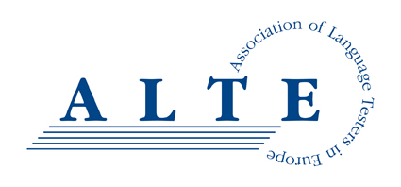
Handling Complaints Policy

ALTE aims to provide high quality services and resources to meet our charity’s objects set out in our constitution and thus meet the needs of our members and stakeholders in the language assessment community. We believe we achieve this most of the time. If we are not getting it right please let us know.
In order to ensure our services remain at a high and improving standard, we have a procedure through which you can let us know if, for any reason, you are not satisfied with your dealings with ALTE. This may be regarding the trustees, our committees or SIGs, the Secretariat, the courses, quality management audits and other consultancy activities we run, or something else.
Please note that complaints regarding a Member of ALTE or their tests should be directed to that organisation.
General complaints
If you wish to make a complaint, please let us know. As a first point of contact, you should get in touch with the ALTE Secretariat (by email secretariat@alte.org, or phone +44 1223 552828). We aim to give you at least an initial response within five working days. If the matter is more complicated, it may take longer to find a resolution.
Auditing (QMS) complaints
If you are not happy with the Auditing (Quality Management System) process, please follow the procedure regarding Conflicts or disagreements found in the Procedures for Auditing document available from https://www.alte.org/Setting-Standards .
Escalating a complaint
If you are not satisfied with our response or wish to raise the matter more formally, please write to the Secretary-General. (If your complaint is about the Secretary-General, please write to the Chair of the Board of Trustees).
The aim is to investigate your complaint properly and give you a reply within ten working days, setting out how the problem will be dealt with. If this is not possible, an interim response will be made informing you of the action taken to date or being considered.
If after we have responded you are not satisfied, please write to the Chair of the Board of Trustees who will report the matter to the next meeting of the Trustees, which will decided on any further steps to resolve the situation.
For more information about the administration and management of ALTE, including information on who the current Secretary-General and Chair of the Board of Trustees is, please see: https://www.alte.org/Administration-and-Management
ALTE (Association of Language Testers in Europe) is a Charitable Incorporated Organisation, registered in England, Charity number 1184799.

